we define a local procedure within an anonymous plsql block to calculate and display the sum of two number
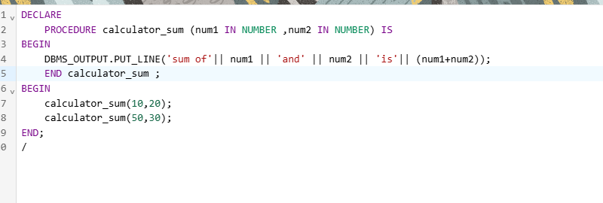
DECLARE
PROCEDURE calculator_sum (num1 IN NUMBER ,num2 IN NUMBER) IS
BEGIN
DBMS_OUTPUT.PUT_LINE('sum of'|| num1 || 'and' || num2 || 'is'|| (num1+num2));
END calculator_sum ;
BEGIN
calculator_sum(10,20);
calculator_sum(50,30);
END;
/

